SECTION IV:

4.

(B) MEAN = 178.2

VARIANCE = 107.95

(A)

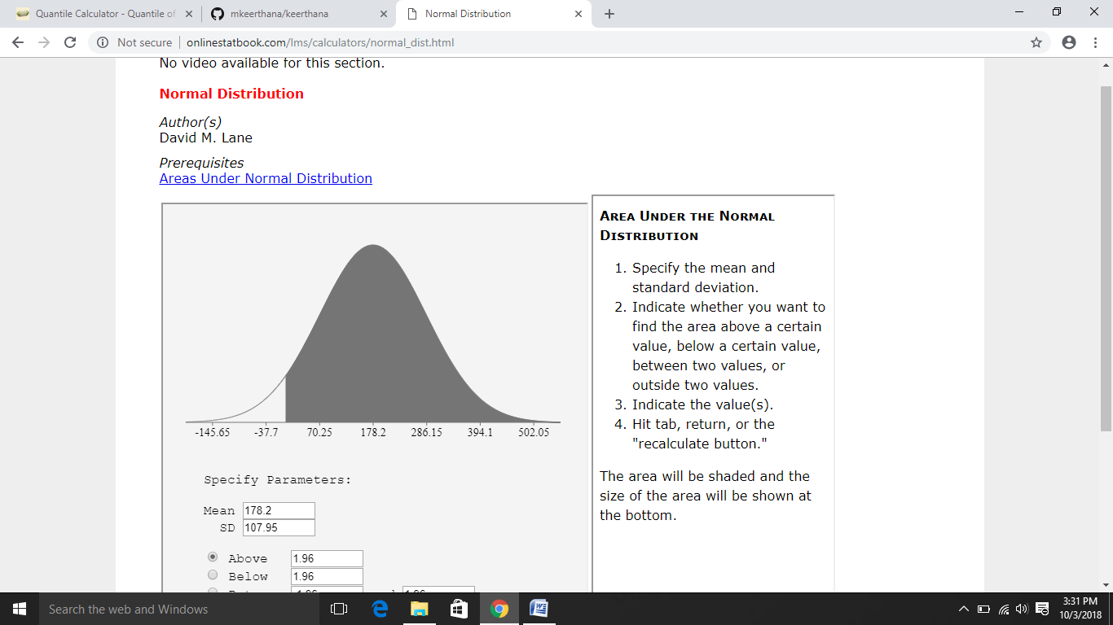

(C)90% CONFIDENCE INTERVAL:

FORMULA: Mean+Z(Variance)

=178.2+1.282(107.95)

=178.2+138.39

=316.59